Update on Johnson County Walmart Appeals at Kansas Supreme Court
By Brad Eldridge, Douglas County, Co-Editor

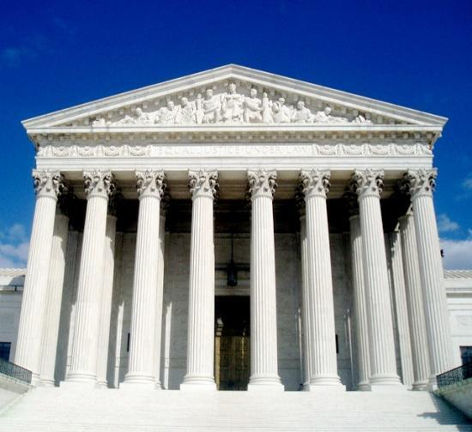

Bota Proceedings

In January 2019, the Kansas Board of Tax Appeals (BOTA) heard cases presented on 11 properties (nine Walmart and two Sam’s Club stores) for the 2016 and 2017 tax years. The taxpayer’s requested values were roughly 50% to 70% of those set by the Johnson County Appraiser’s Office, with an average requested value at 54% of the county’s values.

Representing the county were attorneys Ryan Carpenter and Kathryn Meyers, as well as six expert witnesses, including appraisers Kyle Blanz, RMA (Johnson County BOTA Specialist), Peter Korpacz, MAI, CRE, FRICS, Robert (Robin) Marx, MAI, SRA, and Bernie Shaner, MAI.

Representing the taxpayer was attorney Linda Terrill, who ushered the testimony of eight expert witnesses, including appraiser Gerald Maier, MAI.

The evidence presented focused on fee simple property rights, market value and the use of build- to-suit rent comparables (Prieb decision, Kansas Court of Appeals, 2012). The experts who provided testimony on these subjects are some of the most highly regarded veteran appraisers in our industry.

BOTA concluded value reductions that ranged from 57% to 83% of the county’s values, with an average determination of 63% of the county’s value.

Appeals Court Proceedings

At the request of Johnson County, the Kansas Court of Appeals reviewed the BOTA decision. The Appeals Court published its findings on October 8, 2021. Johnson County contended that BOTA erroneously interpreted and applied the law, that its decision was not supported by substantial competent evidence, and that its decision was unreasonable, arbitrary, or capricious.

The Court of Appeals affirmed BOTA’s decision in favor of the taxpayer (Walmart).

Kansas Supreme Court

Johnson County has filed the matter with the Kansas Supreme Court, asking it to make determinations on the following issues:
- Whether the Prieb court stepped outside its judicial review function by ruling on matters
of generally accepted principles of real estate appraisal instead of limiting its ruling to matters of law.
- Whether the Prieb decision improperly limits BOTA’s ability to weigh the evidence, credibility of experts and differing appraisal methodologies when making valuation decisions.
- Whether Prieb is supported by proper legal or statutory authority, and
- Whether the Court of Appeals inappropriately relied on stare decisis in these matters.
The Kansas Association of Counties (KAC) filed an amicus brief that was granted by the Kansas Supreme Court on February 18. For those of you playing Assessment Acronym Bingo (AAB) at home — that’s eight plays and you should have a win by now.

What Is An Amicus Brief?

This is not a type of Underoos that bears your favorite Greek super hero. An individual or organization that is not party to a legal matter can file as an amicus curiae party — translated from Latin as “friend of the court.” Amicus briefs are typically filed where broad public interests are involved and may apply in situations where civil rights are in question.

In this case, KAC was approved as an amicus curiae because it is a quasi-public agency which seeks to advance the public interest by promoting effective, responsive county government in Kansas. In particular, the Prieb decision and its application impacts counties in Kansas beyond the single county (Johnson) that is party to the action at the Supreme Court.

What Is Stare Decisis?
The fourth issue brought by Johnson County is stare decisis. No, this is not the decision-making process of challenging someone to a staring contest (I recommend never challenging an owl to a staring contest — they will always win). Stare decisis is a rule or matter of law determined by a previous legal case.
In this situation, there is evidence that the Prieb decision inappropriately pushes BOTA to make broad pronouncements about real estate valuation practice and conflicts with other statutory authority.

The Court of Appeals decision for this matter included a 10-page dissenting opinion that questions the soundness of Prieb because its weak foundation that leads to sweeping applications in real estate valuation/taxation, as well as resulting in rejecting expert testimony that leads to an unfair hearing.

Timeline

The timeline of events going forward in 2022 is impacted by when the amicus brief is filed.
- Amicus brief due March 21
- Typically, amicus briefs are due 30 days prior to argument, so the argument before the Supreme Court would not be earlier than April 20.
- The Supreme Court opinion could be released any time after argument. Opinions typically are released on Fridays.
- If the argument happens in April, it is not likely that the opinion would be released prior to June.
- If the argument doesn’t happen until late April, then the opinion will likely happen in July.
- The Supreme Court may be sensitive to the fact that BOTA hearings will be impacted by this ruling and may release an opinion more quickly to avoid disruption.

Based on this information, we should have guidance by the end of the year from the highest court in our state as to whether the Prieb decision has influence on the valuation of real estate in Kansas. Until then, be careful with your staring contest versus your computer screens!

Sources: Jay Hall, Attorney for Kansas Association of Counties, and Ryan Carpenter, Attorney for Johnson County; Images from Bing

