Don’t Forget the Visuals
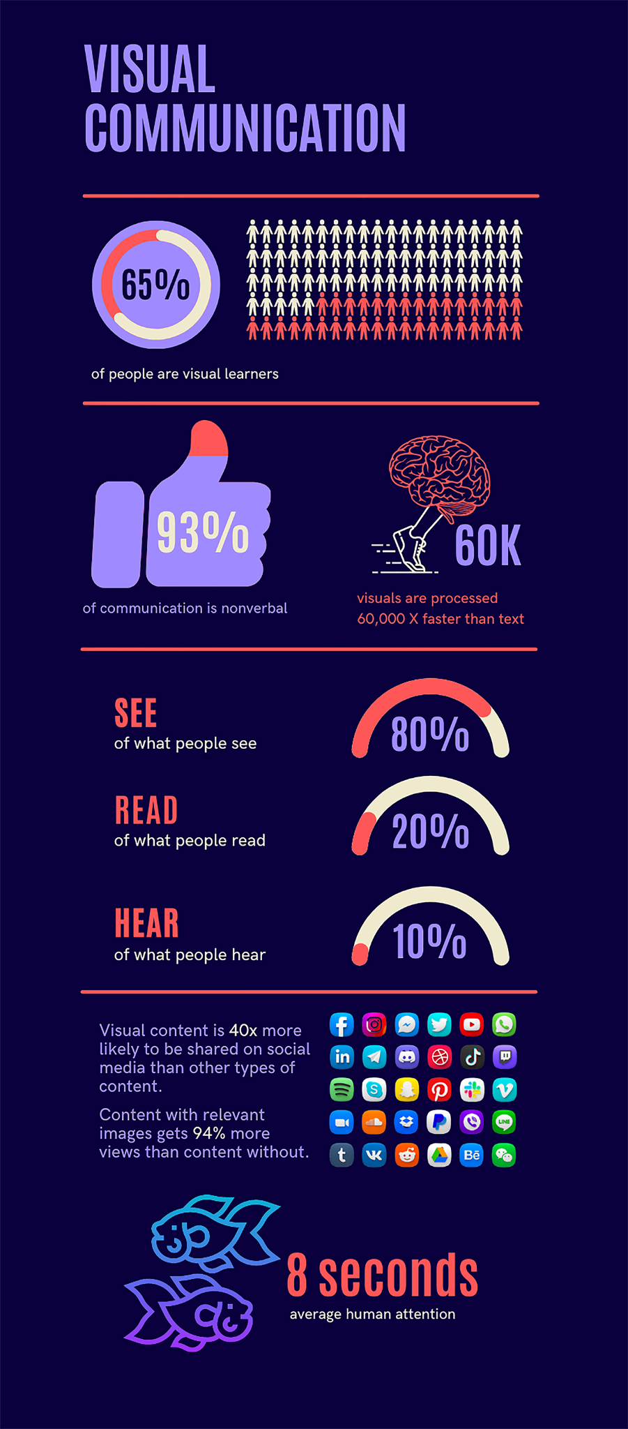

By Janae Robbins, Wyandotte County, Staff Writer

As appraisers, we are responsible not only for valuations, but for communicating that information to countless stakeholders with varying degrees of knowledge and understanding of our process. While we cannot control the market, we can control how our data, processes and regulations are communicated to these stakeholders.

Visual communication, known as ‘viscom’ (we always need more acronyms), is powerful, impactful and is impossible to ignore. Visual content is an effective way of communicating data and can stimulate an emotional connection. Visual content does what text alone cannot.
Graphics affect a person cognitively by increasing data comprehension and retention. Infographics, photos, videos, memes and illustrations are examples that have a major impact on the way people process information. Images can affect our emotions, stimulate creative thinking and influence how we make decisions. Visual communication has the ability to reach people despite language, geographical and cultural differences.

Visual content is processed in the brain’s long-term memory, while words are processed in our short-term memory. Hence the phrase, “in one ear and out the other.” On average, a person gets distracted after eight seconds. For reference purposes, it takes longer than eight seconds to recite the header of K.S.A. 79-503a. Fair market value defined; allowable variance; factors to be considered in determining fair market value; generally accepted appraisal procedures and standards to be utilized. People tend to retain about 10% of what they hear, 20% of what they read and an overwhelming 80% of what they see. It is estimated that the brain can process visual content 60,000 times faster than text. Comprehension also increases when images are paired with text.

Visual communication is more effective because the brain can process, retain and understand more information quickly. As mass appraisers, we deal with large quantities of data and rely heavily on statistics that can easily be displayed visually. Visuals such as charts, graphs and diagrams are common tools used to display mass quantities of data — at times complex — into simple, easy to understand content. Far less time is needed to prepare and present information to a group if visual content is utilized. Unlike paragraphs of text, visual content is easier on the eyes and keeps the audience engaged. It requires less mental processing to understand the information being presented.

There are limitations to visual communication. Small quantities of data are not always visible as there is a limit on how much information can be displayed on a scale. Visual communication cannot be the only form of communication available. Text and audio are necessary — and essential in some instances. For example, this article.

Visual communication can be presented in many ways. Slide deck presentations, like Power Point, are an easy way to display information utilizing visual content and text. Brochures are a great resource to highlight key points and spread your message. Infographics have the ability to tell a story or explain a concept and are typically easily understood by the user. YouTube videos are a great way to share information and processes audibly. Animated videos and graphics can be a fun way to share information and keep the user engaged. Memes can tell a story with just a few words and a meaningful image. They tend to attract a lot of attention and are shared on a multitude of digital platforms. Social media is the most popular way to share information these days. Facebook, LinkedIn, Instagram, Twitter, Pinterest and Snapchat are great ways to communicate with different stakeholders and open the door for community engagement and connection.

When it comes to content creating tools, Canva and PowerPoint are easy-to-use starting points.
Canva is a graphic design platform, used to create social media graphics, presentations, posters, documents, videos and other visual content. It is accessible by website or as an app. Canva is free and has paid subscriptions options such as Canva Pro and Canva for Enterprise for additional functionality. PowerPoint is a powerful, easy-to-use, interactive presentation program that allows the user to create professional-looking slideshows. PowerPoint is free on Microsoft’s website once logged in and offers a paid subscription called Microsoft 365 access to additional functionality.■

